**GUIDELINES FOR AUTHORS FOR PREPARING ABSTRACTS**

First A. Author1, Second B. Author1, Third Author2, and Fourth C. Author3,[1]

1**Ö**zyeğin University, CEEE/EÇEM, Istanbul, Türkiye

2The Cyprus Institute, Nicosia, 2121, Cyprus

3University of California, Los Angeles, CA 90095, USA

# ABSTRACT

**Overview**

This guide has been prepared for authors of abstracts to be presented at the First International Symposium on Low-Carbon Energy Science and Technology (LCET-2025) to be held in Istanbul, Türkiye, 15–17 October 2025. Abstracts are expected to provide a very concise description of the work being presented. They must clearly state the purpose, the methodology, the main results and the originality of the study. They must be submitted electronically in PDF format via e-mail ([w.lipinski@cyi.ac.cy](mailto:w.lipinski@cyi.ac.cy)) to Prof. Wojciech Lipiński, Symposium Co-Chair. The main format of the abstract is as follows:

* Pages: **max. 2 pages including references**; page numbers must be included on each page, centered at the bottom; page size A4 (210 × 297 mm); 20 mm borders all round;
* Text: Times New Roman (or equivalent), 11pt font size, left and right justified, single-spaced; the first page should be completely filled with typing and/or diagrams;
* Paper title: Times New Roman 12pt font size, all bold capital letters (except if formulae or symbols appear in the title), centered on the width of the typing area; the title should be brief, clear and descriptive; one blank line between the title and the affiliation(s);
* Section headings: Times New Roman, bold, 11pt size, left aligned, preceded by one blank line except the first section; do not use subsections;
* Paragraphs: Use 0.5-cm indentation except for the first paragraph in each section.
* Equations and symbols: Time New Roman 11pt font size; assure all symbols and equations are correctly displayed in the PDF version;
* References: Number consecutively in the order of appearance[1], using Arabic numerals in square brackets [2–5]; Times New Roman, 10pt font size, left–right justified, first line flush left, remaining lines indented.

Any word processing utility (*e.g*. MS Word, LibreOffice, LaTeX) may be used to generate the manuscript provided it is converted to PDF for submission and follows the format shown in this template.

**Equations**

Equations should be typed neatly in position with a single line space above and below. Equations should be centered and assigned a number that should appear in parentheses flush to the right margin.

 (1)

and

 (2)

Subscripts and superscripts should clearly be typed as such. Ensure that there is no ambiguity in the use of symbols. Align equal signs when equations stack with no intervening words. All data should be reported in SI units. Decimals should always be shown by periods, not commas or centered dots.

**Figures and tables**

All figures and tables should be contained within the typing area and must not be split between pages. Lettering in the figures should be comparable to that in the text. Colour and black and white figures/photographs are allowed in digital format with sufficient resolution to permit high-quality reproduction. Figures should be numbered consecutively and referred to in the text unabbreviated, *e.g*. Figure 1, with a single letter space between the word “Figure” and the Arabic numeral. Enclose units in round parentheses. Place figures centered on the width of the text page as close as possible to their first mention in the text. Centered one line below the illustration, type the word “Figure” and its number followed by a period, one-letter space, and the actual caption text. Each illustration should have a one-line space above and below the figure.

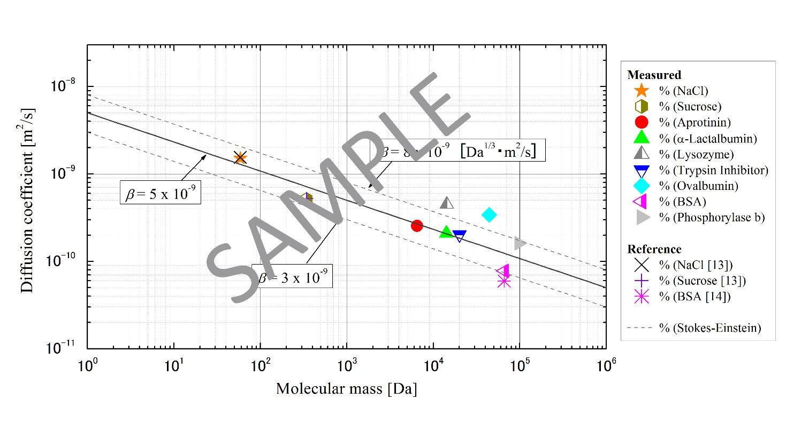

Figure 1. Figure captions are centered under the figure.

The same rules apply to tables except the word “Figure” is replaced with “Table”. In tables, use horizontal rules above and below to separate title from column heads, ranks within column heads, column heads from table body, and table body from table footnotes or source.

Table 1. Comparison between theory and experiment

|  |  |  |  |  |
| --- | --- | --- | --- | --- |
| Date of test | Theoretical value  (cm) | | Experimental value (cm) | |
|  | Left | Right | Left | Right |
| January 1 | 17.45 | 3.81 | 16.98 | 3.99 |
| March 3 | 21.43 | 6.45 | 22.56 | 6.91 |

**Authors from non-English speaking countries**

Authors from non-English speaking countries are requested to find persons who are competent in English and familiar with the scientific language who can edit their manuscripts before submission. Reviewers must not be relied upon to make corrections of English expression or spelling. As there is no copy editing stage for publication-ready manuscripts, it is the responsibility of authors to ensure that the presentation of their papers reaches the same high level as that of the work they describe.

**Conclusions**

All abstracts will be reviewed by the Symposium Chairs. Any abstract which does not address new and innovative aspects in the topics of the meeting may not be selected for presentation at the Symposium. In order to process the reviewing in time, please submit your manuscript in PDF format no later than **1 July 2025** to Prof. Wojciech Lipiński, Conference Co-Chair, e-mail: [w.lipinski@cyi.ac.cy](mailto:w.lipinski@cyi.ac.cy).

# Acknowledgements

Acknowledgement, if any, should be placed immediately following **Conclusions**.

**References**

[1] M. P. Menguc, R. Viskanta, “Radiative Heat Transfer in Three-dimensional Rectangular Enclosures Containing Inhomogeneous, Anisotropically Scattering Media”, *J. Quant, Spectrosc. Radiat. Transfer*, vol. 33, no. 6, pp. 533–549, 1985.

[2] M. F. Modest, *Radiative Heat Transfer*, Third Edition, Academic Press, pp. 125–126, 2013.

[3] G. Erdas, “Free Vibration Analysis of Beams and Plates Using Finite Element Method”, M.Sc. Thesis, METU Mech. Eng. Dept., Ankara, 1983.

[4] F. Liu, J.-L. Consalvi, A. Fuentes, G. J. Smallwood, “Effects of Water Vapor Addition to the Air Stream on Soot Volume Fraction and Flame Temperature in a Laminar Coflow Ethylene Flame”, In *Proceedings of the 7th International Symposium on Radiation, Kusadasi, June 2-8, 2013*, paper RAD-13-CO2, 2013.

1. Corresponding Author: [f.author@affiliation.com](mailto:f.author@affiliation.com) (Times New Roman, 10 pt).